**Assignment Name**: **Lab5:** (**IPO, Design, Trace)**

**Due date:** **10/12/2022, by 11:00 am.**

**Grade for assignment: 30** points

**Purpose:** Obtain experience in analysis using the Input Process Output (IPO) tool and realize the importance of security in software development. Assignment accomplishes course learning objective “analyze problems and design structured solutions”. Assignment also provides preparation for COSC236 course, and enhances skills needed in Information Technology (IT) and Computer Science industries.

**Skills:** Purpose of assignment is to help you practice the following skills.

-Ability to utilize the IPO tool

-Ability to do a Trace

-Able to write efficient computer program

**Knowledge:** Become familiar with using the Software Development Life Cycle (SDLC).

**\*\*\*\*\*\*\*\*\*\*\*\*\*\*\*\*\*\*\*\*\*\*\*\*\*\*\*\*\*\*\*\*\*\*\*\*\*\*\*\*\*\*\*\*\*\*\*\*\*\*\*\*\*\*\*\*\*\*\*\*\*\*\*\*\*\*\*\*\*\*\*\*\*\*\*\***

**Place your Name(s) below:**

**Pairs work:** Please work in pairs. **One student in team should submit work**. Put **your first and last name on the assignment** and **your partner’s first and last name on the** assignment

**Note(s):**

1. All programs should be completed within the Visual Studio Code environment. There are guides in blackboard to start you off with Visual Studio Code.

**Partner 1: Name ______________________________________________**

**role (did the typing or read and review) _____________________________**

**Partner 2: Name ______________________________________________**

**role (did the typing or read and review)______________________________**

**Please note if one partner did not work on all problems.**

**Submission instructions:** All submissions will be done using blackboard. **Answers are to be submitted in a Microsoft word document.**

**Task**:

**Examples:** Refer to your notes from class, the Introduction PowerPoint,Operator PowerPoint, in class exercises and any available videos (located in Blackboard).

**Part1 (20 points):**

Input the length and width of a room and calculate the area and the perimeter. Display all values.

|  |  |  |
| --- | --- | --- |
| Input | Process | Output |
| rmlength | **Input** rmlength, rmwidth | rmlength |
| rmwidth | Calculate rmArea, rmPerimeter | rmwidth |
|  | Display rmArea, rmPerimeter , rmlength, rmwidth | rmArea |
|  |  | rmPerimeter |

For finding the **perimeter** use formula: perimeter = 2 x (length + width)

For finding the **area** of use formula:   area = length x width

1. Use the formulas for perimeter and area to write the C++ code for the IPO above.
2. Write a Trace testing with different values for input. (Use values: 0, and any positive numbers)
3. Test to determine if runtime behavior match the trace results?
4. **SUBMIT your code, and sample of output (Below):**

**Trace**:

|  |  |  |  |  |
| --- | --- | --- | --- | --- |
|  |  |  |  |  |
|  |  |  |  |  |
|  |  |  |  |  |
|  |  |  |  |  |
|  |  |  |  |  |
|  |  |  |  |  |
|  |  |  |  |  |
|  |  |  |  |  |
|  |  |  |  |  |
|  |  |  |  |  |

**Part2 (10 points):**

1. Copy and paste the link below into a Google web browser and complete Integer Error Security Injection.

<http://cis1.towson.edu/~cyber4all/modules/nanomodules/Integer_Error-CS0_C++.html>

1. **SUBMIT copy of Security Injection certificate(s) (Below):**

**\*\*\*\*\*\*\*\*\*\*\*\*\*\*\*\*\*\*\*\*\*\*\*\*\*\*\*\*\*\*\*\*\*\*\*\*\*\*\*\*\*\*\*\*\*\*\*\*\*\*\*\*\*\*\*\*\*\*\*\*\*\*\*\*\*\*\*\*\*\*\*\*\*\*\*\*\***

**Criteria for Success**:

**a**) Be sure to submit your code and output above for each question; **Submission of Code and output is required**. (Note: use screen shots or copy and paste).

For example if the assignment was to write a program that displays “Hello World”

Your **code** would be as follows:

//Lab1 answer COSC175002

#include <iostream>

using namespace std;

int main()

{

cout << "Hello, world" << endl;

system("pause");

} // end of main

Your **output** would be as follows:

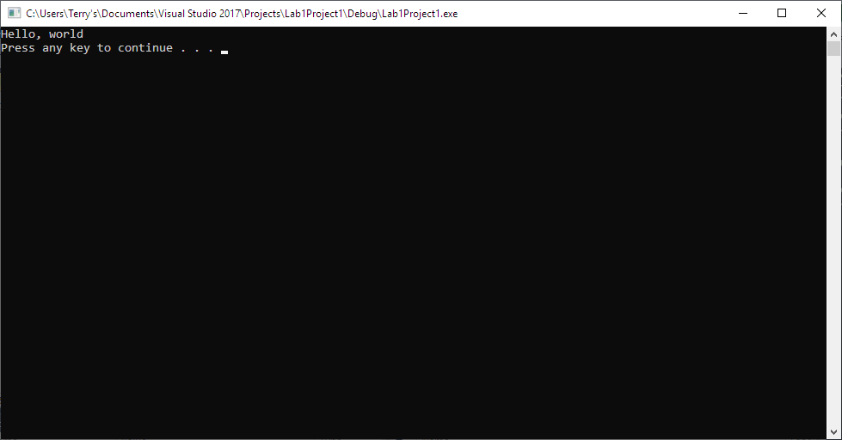

Note: To avoid additional point deductions; remember to submit both code and output.

>>>

**b)** Be sure to show completion of Security Injections by providing Screen shots of (or copy and paste) your Security Injection completion **Certificate** above**. Do not email me your certificate.**

**c) Late policy:** Late submissions will receive a zero grade. Get help during the week so that you can submit on time.